1. Comment on how well your range finder works (Is it linear? does it give the correct result?).

b. Comment on to what accuracy you would trust your range finder (this is an estimate, we have not discussed statistically how to make these judgments in a more formal way!). 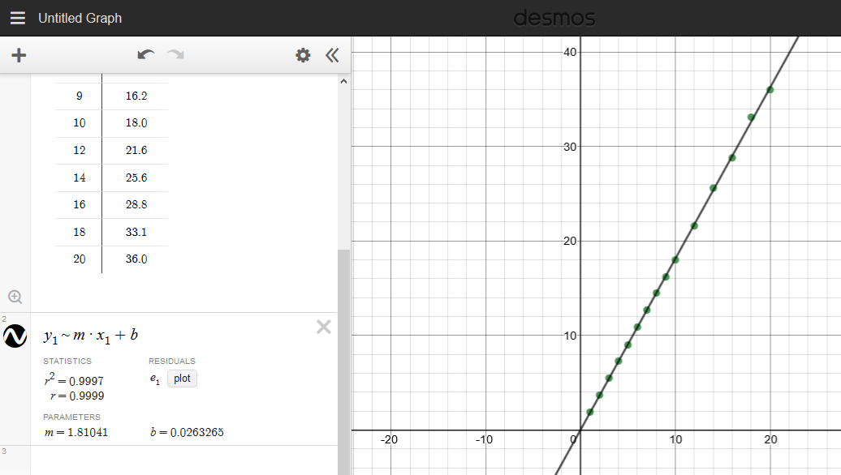

Above there are requests for 5 figures; Keep your lab report focused on these 5 figures.